Practical Guide on QuickBooks by Meru Accounting

Table of Contents:
1. Understanding the basic features in QuickBooks Application …………………..
1.1. Login to QuickBooks …………………………………………………………………………….
1.2 QuickBooks Dashboard …………………………………………………………………………
1.3. QuickBooks Menu ………………………………………………………………………………..
2. Understanding the QuickBooks Dashboard …………………………………………….
3. Banking …………………………………………………………………………………………………..
3.1. Banking ……………………………………………………………………………………………....
3.2. Rules ……………………………………………………………………………………………………
4. Expenses ………………………………………………………………………………………………..
4.1. Expenses ……………………………………………………………………………………………..
4.2. Suppliers ……………………………………………………………………………………………..
5. Sales ……………………………………………………………………………………………………….
5.1. All Sales ……………………………………………………………………………………………….
5.2. Invoices ……………………………………………………………………………………………….
5.3. Customers ……………………………………………………………………………………….....
5.4. Products and Services …………………………………………………………………………
6. Employees ……………………………………………………………………………………………..
7. Reports ………………………………………………………………………………………………….
8. Taxes …………………………………………………………………………………………………….
9. Accounting …………………………………………………………………………………………...
9.1. Chart of Accounts ………………………………………………………………………………
9.2. Reconcile …………………………………………………………………………………………
10. My Accountant …………………………………………………………………………………
11. Apps ………………………………………………………………………………………………….

Details on “SETTINGS” option:
A. Your Company
1. Account and Settings …………………………………………………………………………..
2. Manage Users ……………………………………………………………………………………..
3. Custom form styles ……………………………………………………………………………..
4. Chart of Accounts ………………………………………………………………………………..
5. QuickBooks Labs ………………………………………………………………………………….

B. Lists
1. All Lists ………………………………………………………………………………………………..
2. Products and Services ………………………………………………………………………..
3. Recurring Transactions ………………………………………………………………………..
4. Attachments ……………………………………………………………………………………….

C. Tools
1. Import Data …………………………………………………………………………………………
2. Export Data ………………………………………………………………………………………….
3. Reconcile ……………………………………………………………………………………………..
4. Budgeting ……………………………………………………………………………………………….
5. Audit Log ………………………………………………………………………………………………

1. Understanding the basic features in QuickBooks Application
- QuickBooks is Accounting software which manages important activities of small and medium-sized business like Inventory, Recording of the Transactions, etc.
- The reports can be generated in an easier way to provide the necessary information in the business
- You can minimize your large accounting cost by using the quick books
- A large number of small businesses can use the QuickBooks in a much flexible way
- The online payment feature in this software has made the payment process simpler
- Using QuickBooks can help in bringing more accuracy in making important financial statements like Profit & Loss, Balancesheet, Cash Flow Statement, and several other accounting related reports.
- Roles and permissions can be allotted in a very accurate way
- Payroll Management can be made much simpler way

The 5 Basic functions of QuickBooks:
1. Vendor
2. Customer
3. Employee
4. Company
5. Banking

1.1. Login to QuickBooks
• For login into Quickbooks, just go to the link “https://c18.qbo.intuit.com/qbo18/login?webredir” and then login with proper Username and Password details
• Any of the browsers can be used for running the QuickBooks software

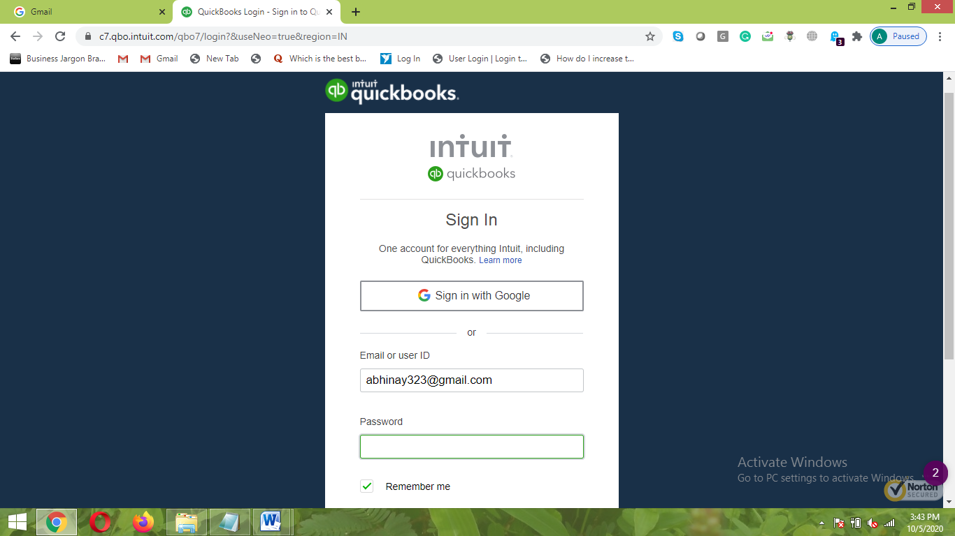

1.2 QuickBooks Dashboard
- Once you Login to QuickBooks, the main page of the QuickBooks application is seen, it is also called as “QuickBooks Dashboard”.
- All the important information can be viewed from here like Invoices, Expenses, Bank Accounts, Profit and Loss, Sales.
- Here you can get the customized reports on all the aspects like Number of days, number of months, and number of years.
- If your company is liable for GST filing then you must fill the details of GST and along with the other company details
- In Dashboard you have the facility to put the Logo which can be reflected in the Invoice
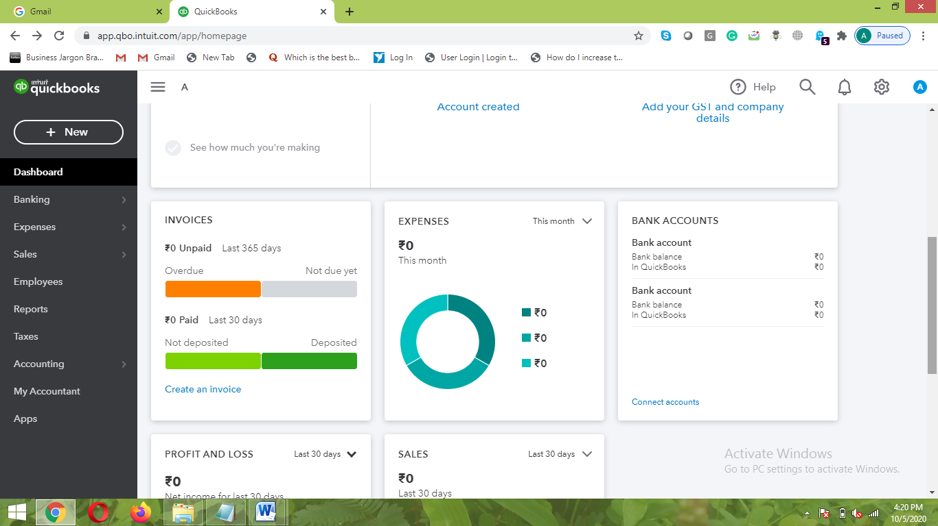

1.3. QuickBooks Menu
- The Menu of QuickBooks is very user-friendly where any of the new person can understand to use it easily
- All the information can be put in a very simple way here
- In coming section, we will look at each of the Menu options in more detail
- Here are some of the important sections of the Menu:
- Banking
- Banking
- Rules
- Expenses
- Expenses
- Suppliers
- Sales
- All Sales
- Invoices
- Customers
- Products and Services
- Employees
- Reports
- Taxes
- Accounting
- Chart of Accounts
- Reconcile
- My Accountant

2. Understanding the QuickBooks Dashboard
- In Dashboard, you can view all the important process of the transactions in business. You can go to any of the functionality in a very simple way here.
- Here, you can quickly add information related to the Customers, Suppliers, Employees, and other Banking related information.
- Through Dashboard you can check important information about the business regarding Invoices, Expenses, Bank Accounts, Profit & Loss, and Sales.
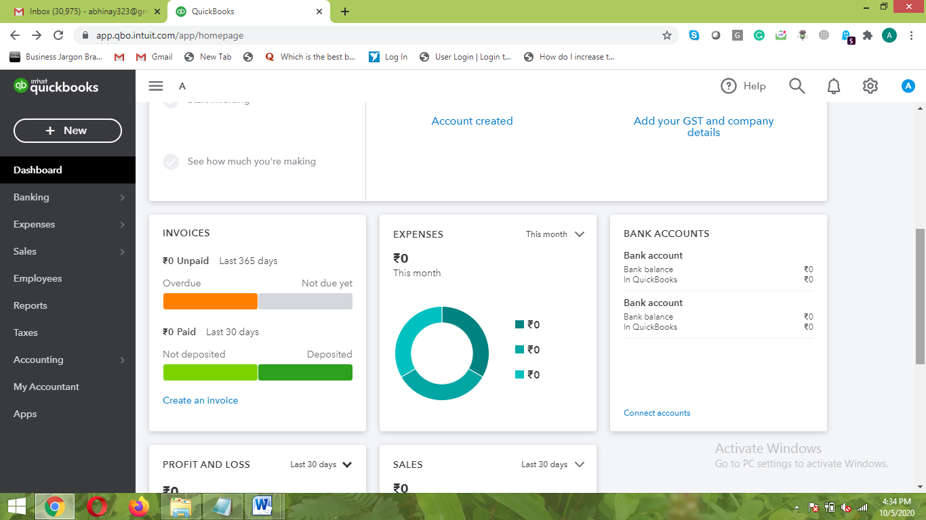

3. Banking
- All the Banking information about the business transactions are reflected here
- Here, you first need to integrate your Bank account of business transactions with the QuickBooks which can be helpful to carry all the Banking information easily
- Banking is further categorized into two sections: Banking and Rules.

3.1. Banking
- Here you can Automate Income and Track the Expenses
Three Simple steps are followed here:
1. Connect a bank or credit card to get started
2. Review and add your transactions
3. See how your business is doing

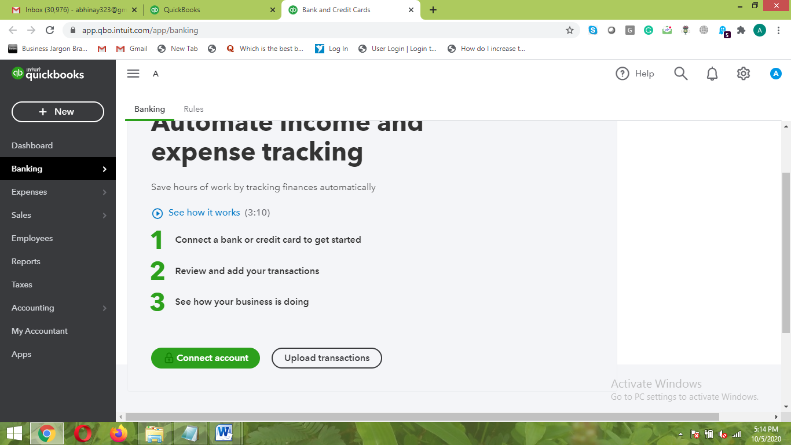

3.2. Rules
- Here, you can give different rules as per the applicability
- You can assign the rule as per the Criteria or Conditions, Priority, Auto Applicability, etc.
- You can assign the particular rule wherever applicable with necessary condition
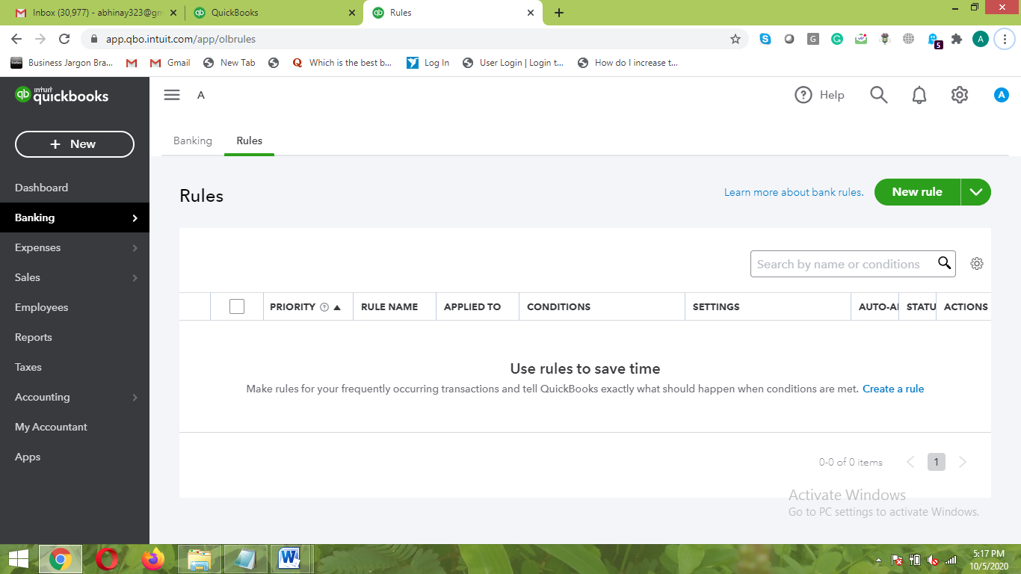

4. Expenses
- In expenses section, you can put all the expenses incurred in the business which can be easier to track later.
- The expenses incurred in the business can also be categorized in different sections
- Expenses are further categorized into two sections: Expenses and Suppliers
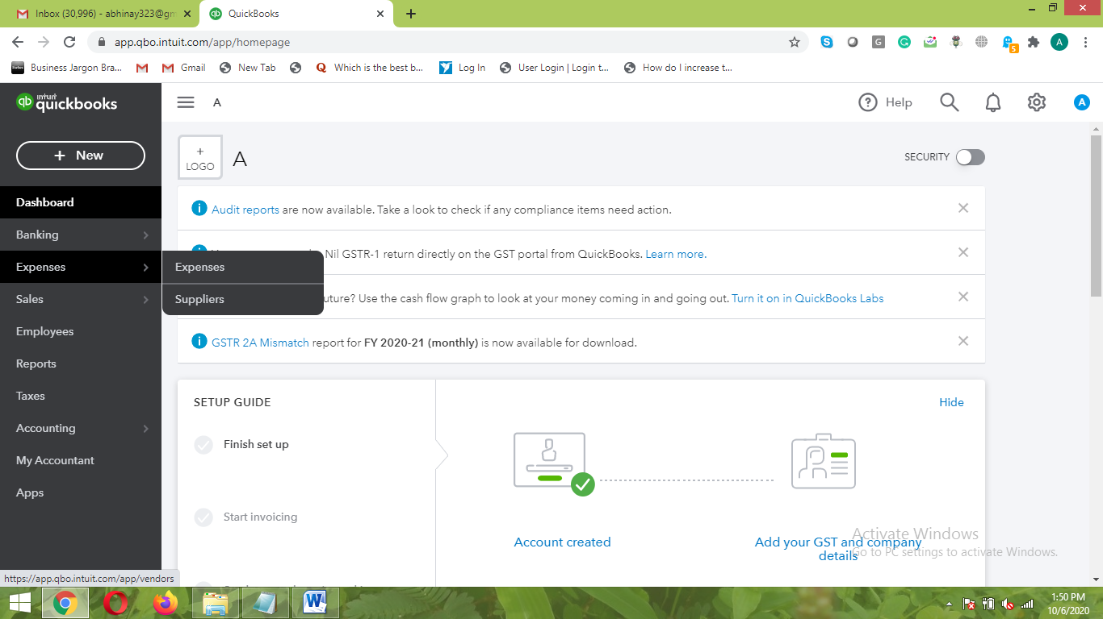

4.1. Expenses
- All the expenses are put here in one place with a clear categorization of spending made in the business
- You can add the expenses manually from the option of “Add Expense Manually”

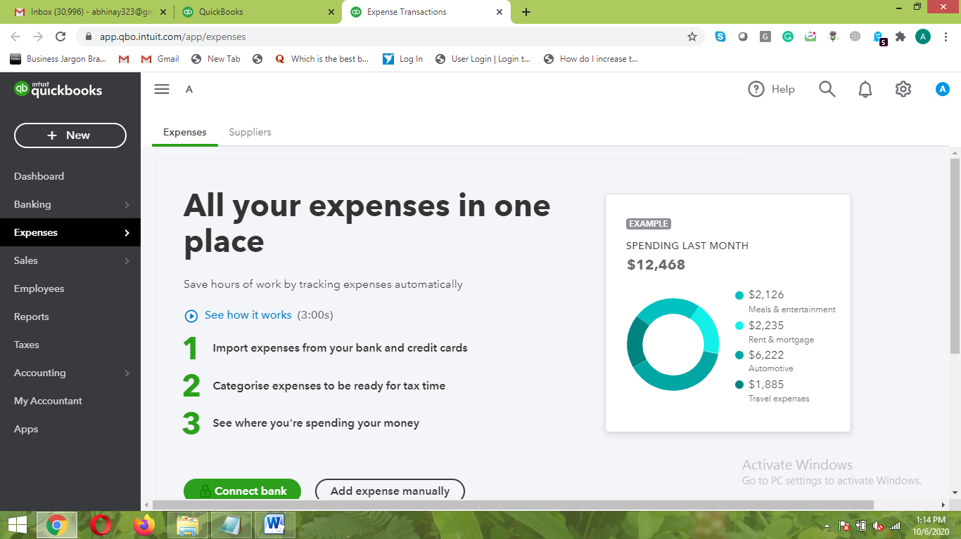

4.2. Suppliers
- Here you can keep the track of the expenses of suppliers for whom you have to pay
- You can add the new suppliers manually through the option of “Add Supplier Manually”.
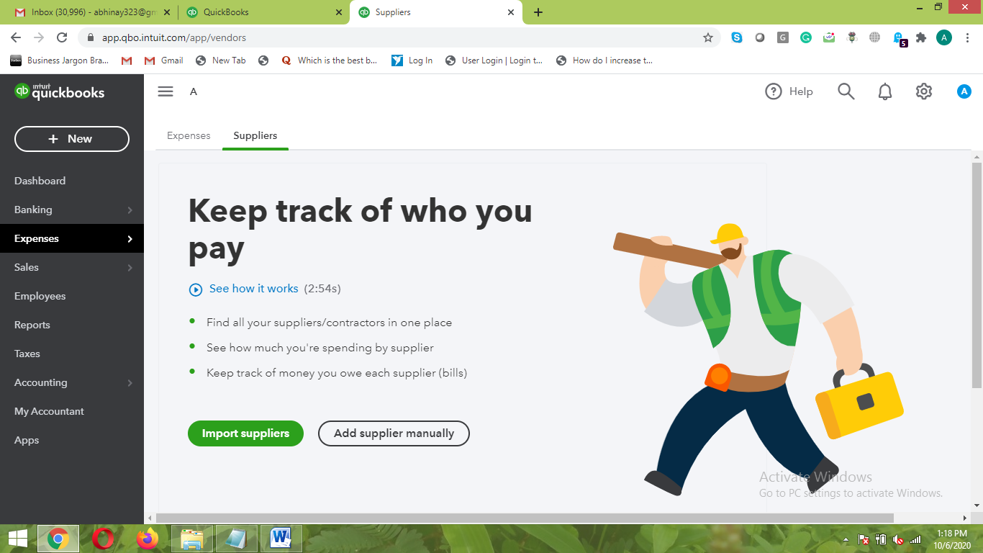

5. Sales
- Here you can keep the record of all the sales made in the business
- You can track all the sales related information involving Customers and the products or services sold
- Sales are further categorized in four sections: All Sales, Invoices, Customers, and Products or Services.

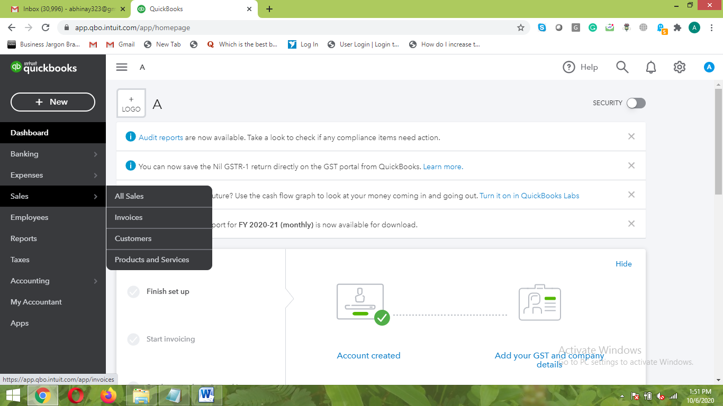

5.1. All Sales
- Here, you can track all the sales made in the business
- The invoices can be created here for the customers from where the payment is supposed to come
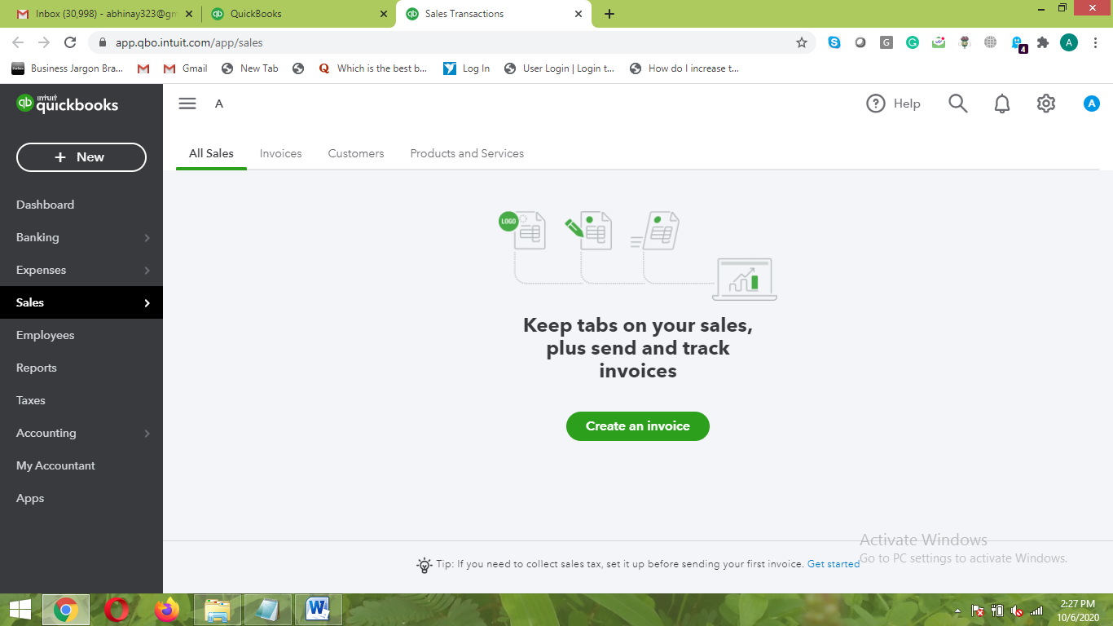

5.2. Invoices
- Here you can create the invoices for the customers and send it to the customer from where the payment will come
- You can get the information of all the Invoices which are not cleared and suppose to pay in a very hassle-free way
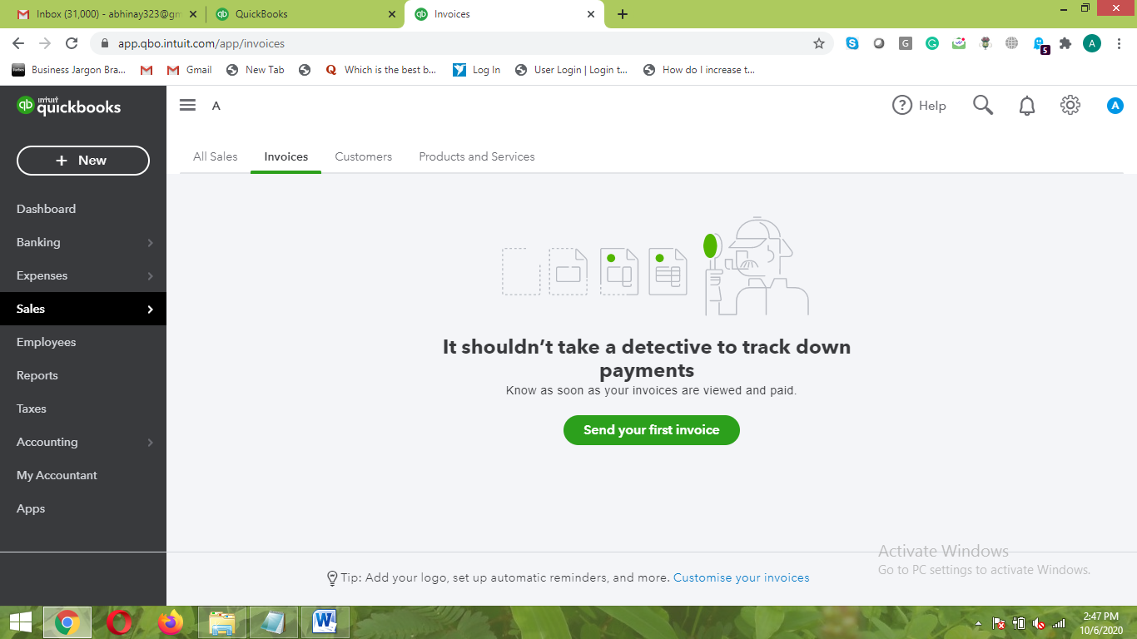
5.3. Customers
- Here you can get the information of all the customers from whom you will be getting the payments
- You can even know the information about your top customers on decided criteria’s
- The customer information can either be imported or added manually
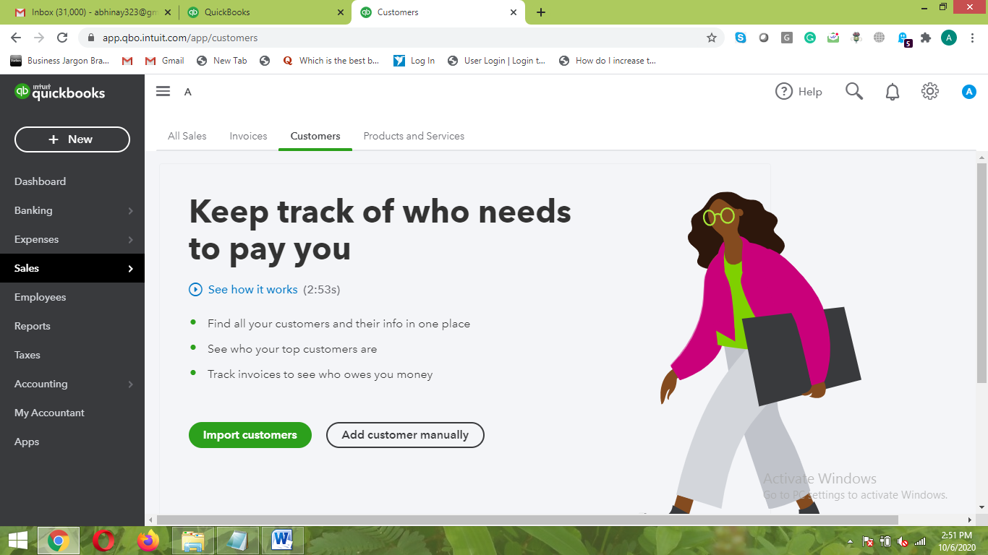

5.4. Products and Services
- You can add the product and service information here at one place
- Here the product can be added through Inventory, Non-Inventory, Service, or Bundle.

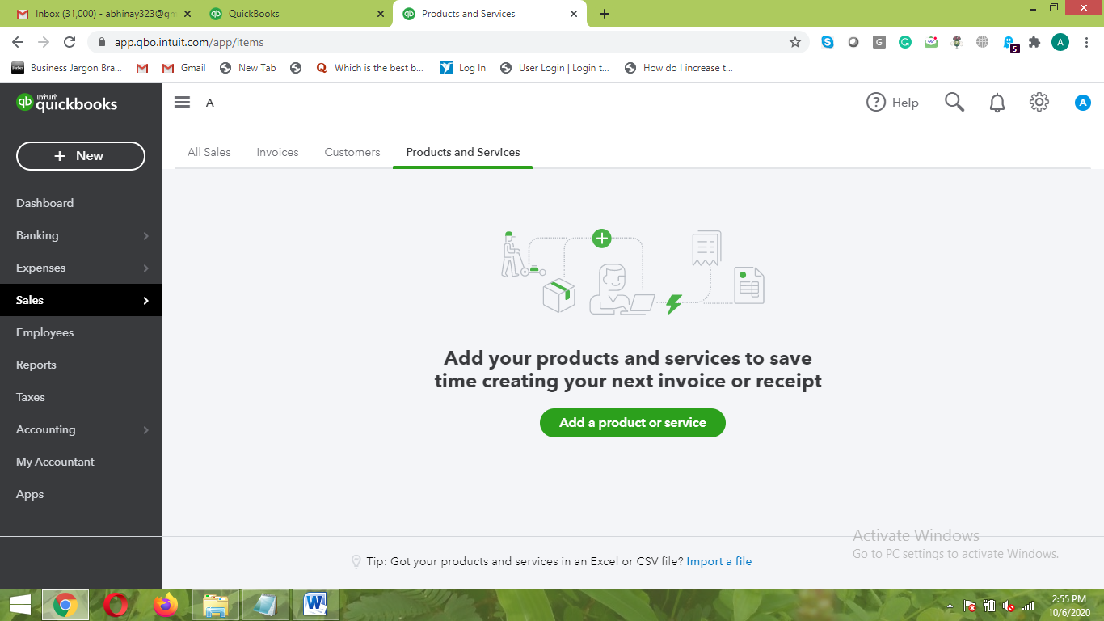

6. Employees
- Here, you can get the information of all the Employees along with their Name, Phone Number, Email Address, and Action
- You can even Add the information of all the Employees through this section in a much easier way
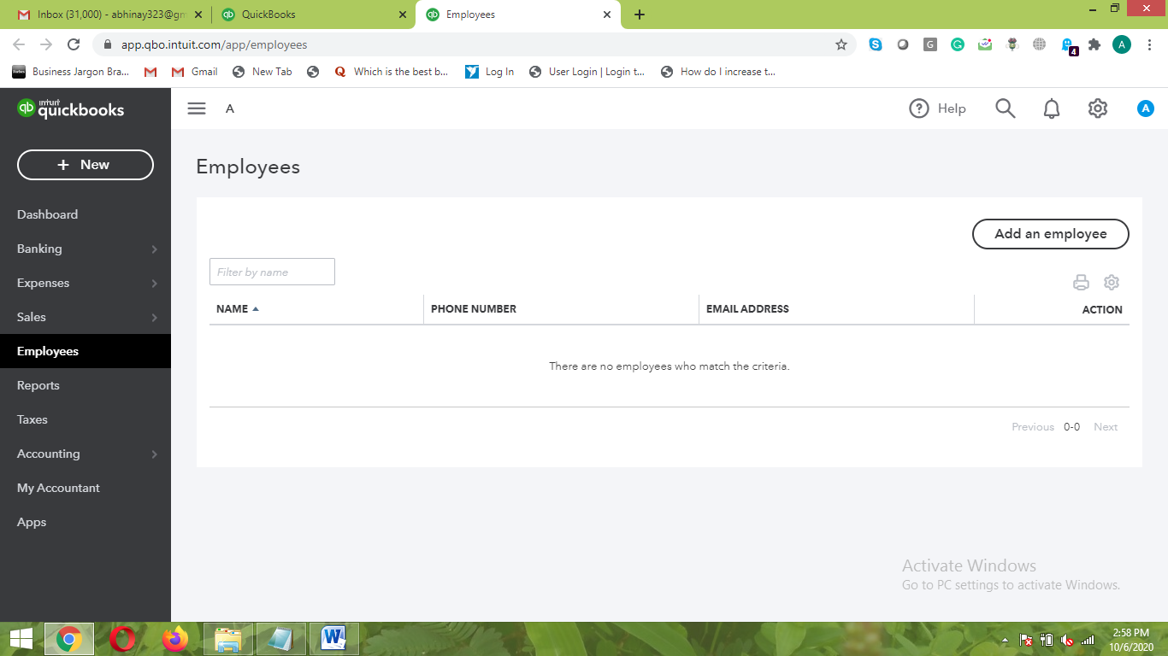
7. Reports
- You can get all the different types of reports from here which are very important from the management point-of-view
- You have the option to select the particular type of report which you need
- The Financial Reports are carved out in a very fantastic way which can give better insights into business
- You can also customize each of the reports as per your need and requirement
- There are three types of reports here like Standard, Custom Reports, and Management Reports

- Glimpse of Standard Reports
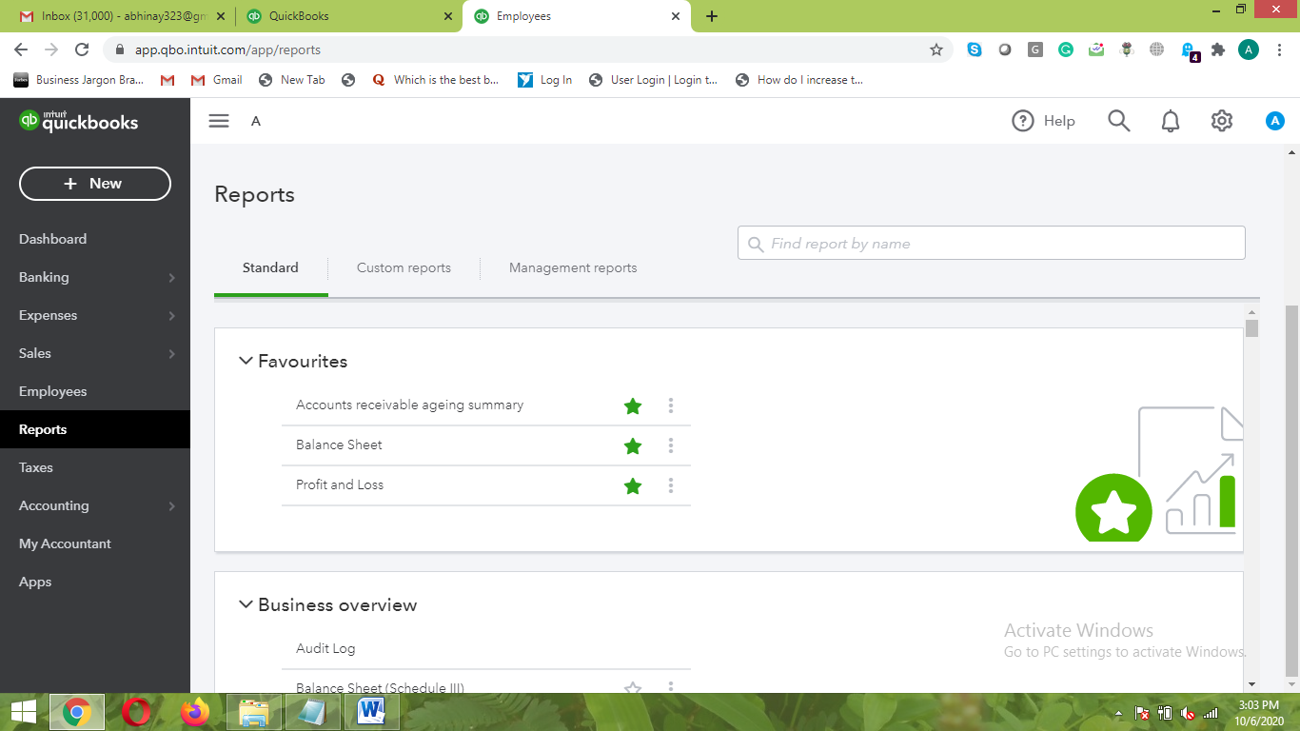

- Glimpse of Custom Reports
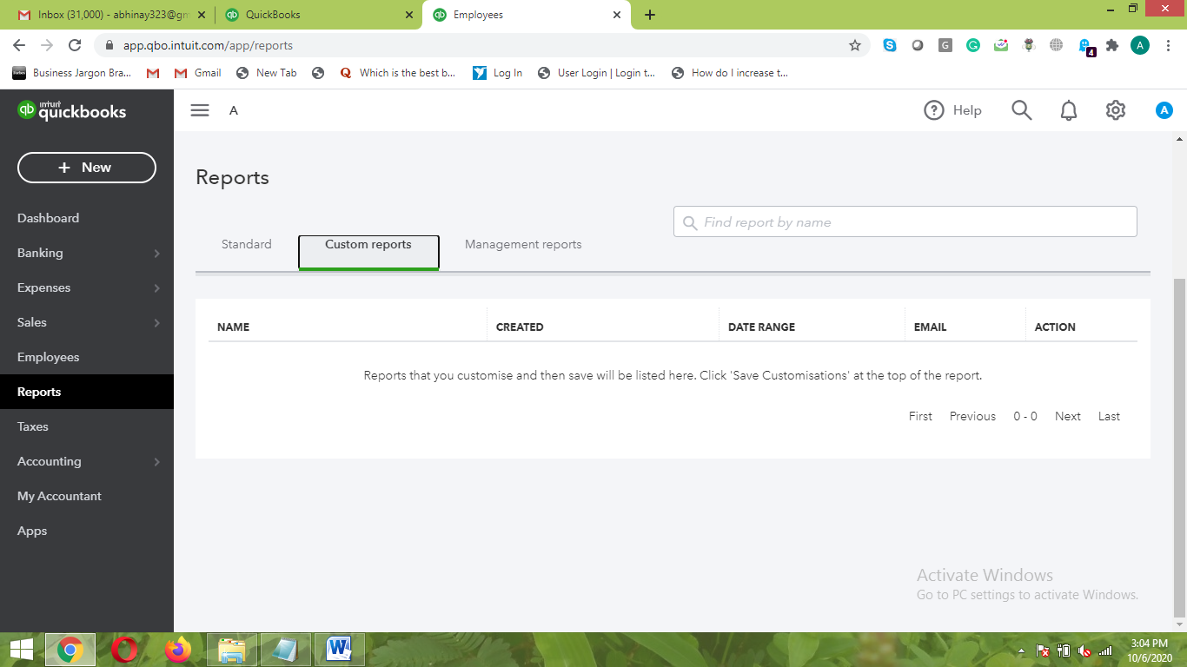

- Glimpse of Management Reports
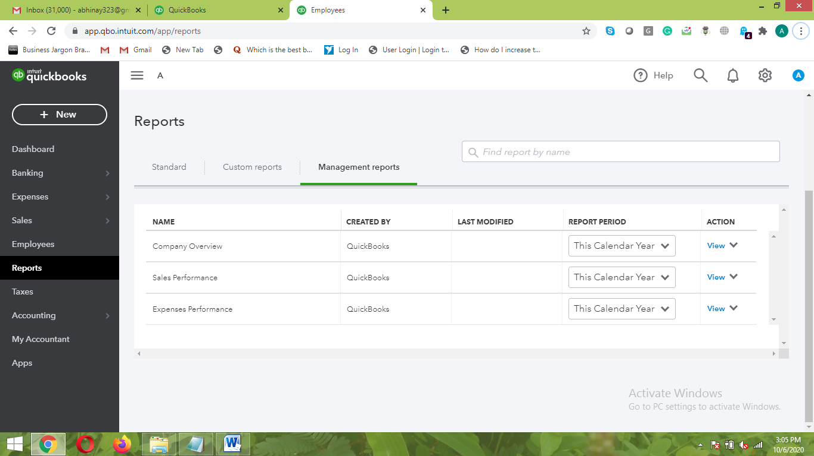

8. Taxes
- Here you can manage the taxes incurred on the business which can minimize the complexity involved during tax filing process
- A clear bifurcation of the IGST, CGST, SGST, and other applicable taxes are made here

- Returns section allows you to make the Tax Adjustment in an easier way
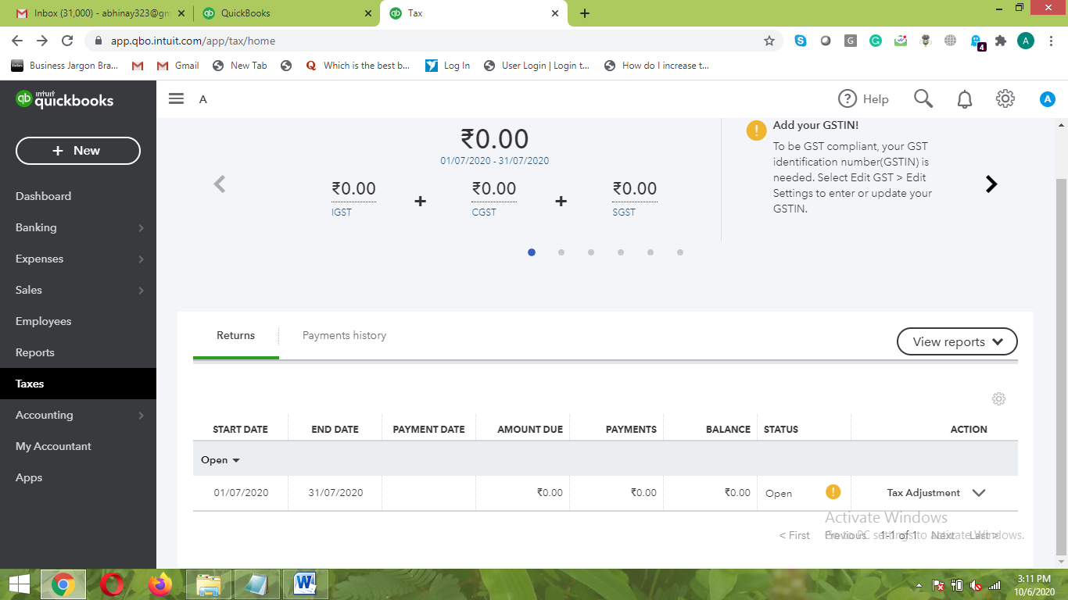

- Payment History can be viewed here in a very easier way
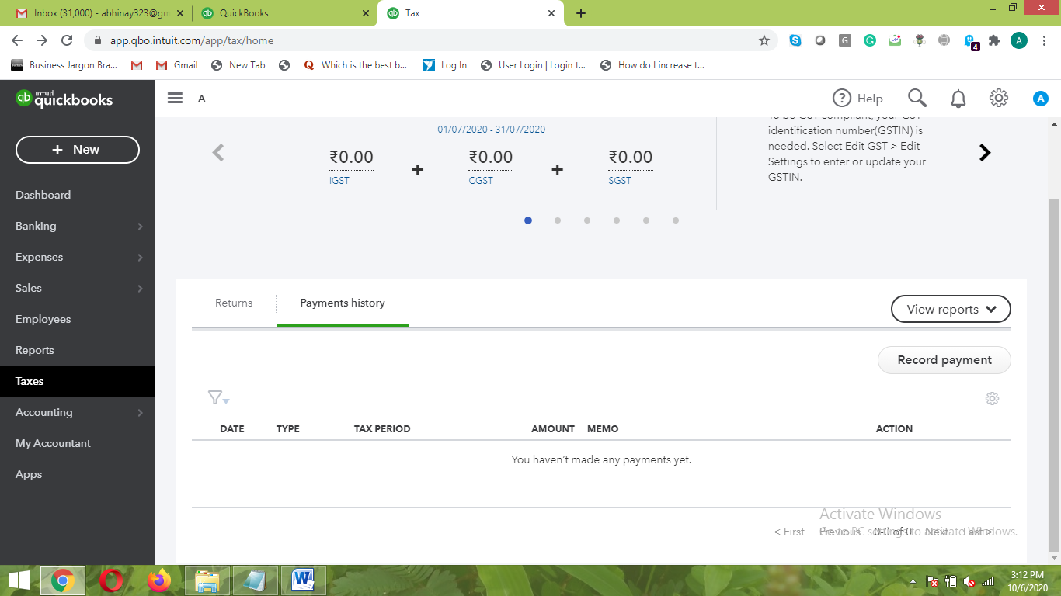

9. Accounting
- Here all the accounting activities of the businesses are considered
- All the transactions history along with proper allocation is made through the accounting section
- Accounting is categorized in two sections: Chart of Accounts and Reconcile
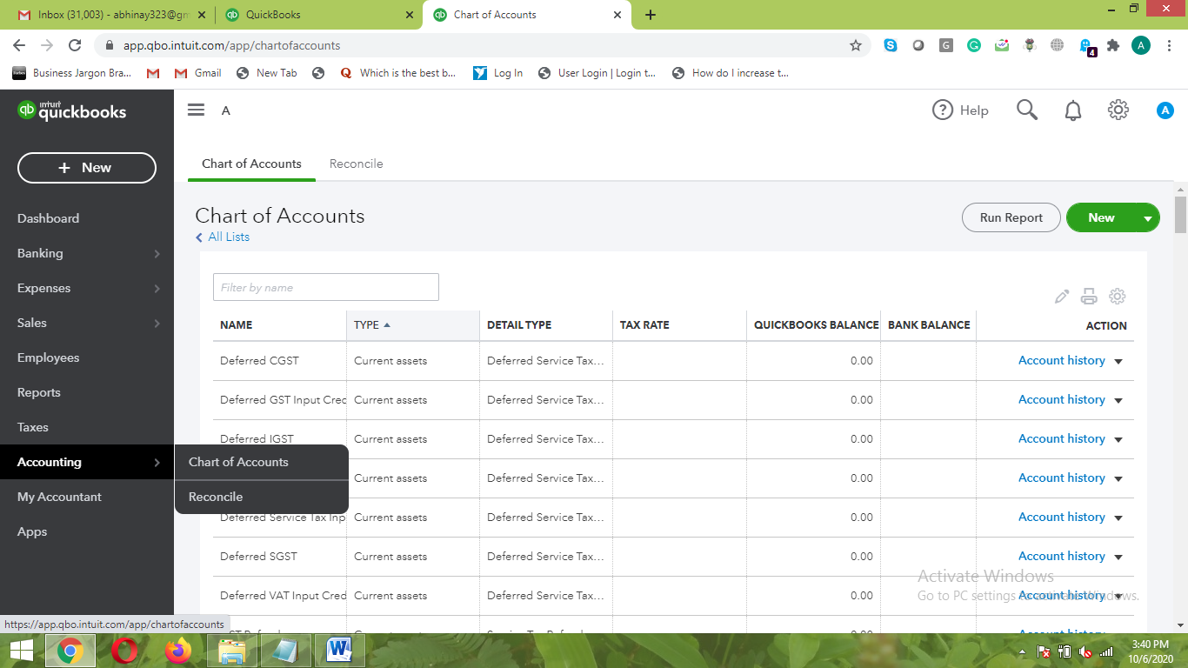

9.1. Chart of Accounts
- This section allows you to view all the transactions made in the business along with related details
- The “New” option here allows you to import the transactions from other locations to QuickBooks
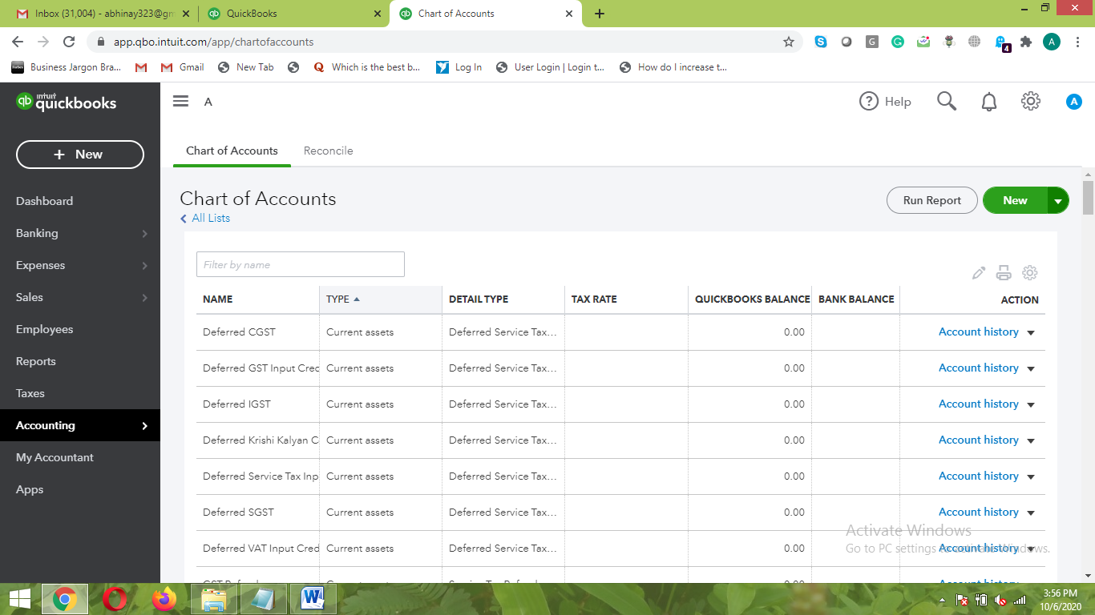

9.2. Reconcile
- This is a reconcile section where you can match the details of books to the bank records
- It helps to keep the transactions about related things in a very neat and tidy way
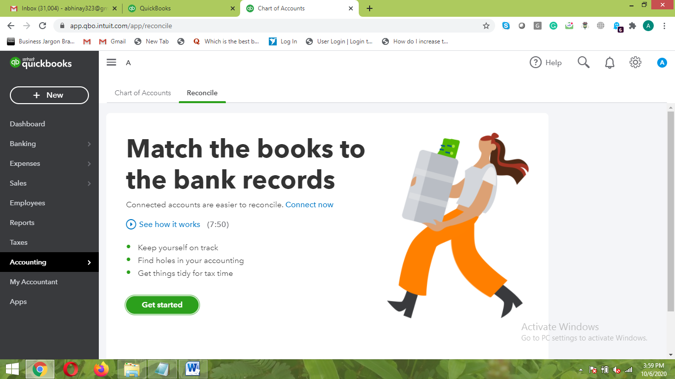

10. My Accountant
- “My Accountant” is a very important section where you can give access to different members in the firm who are related to Accounting
- Generally, these members are Business Owner, Accountant, and other senior managers in the firm which cares related to the accounting
- You just need to put the Email Id of that person and click “Invite” button which will directly give the access
- The admin here can give the different level of access to different individuals in the firm

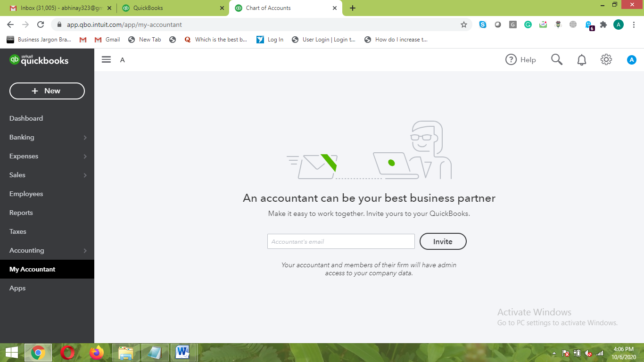

11. Apps
- The “Apps” sections allow you to search for different apps
- Here you can integrate other apps to the QuickBooks as per the business requirement
- A huge category of Apps that serves different purposes is found here. Some of the categories include Popular Apps, Payment Making Apps, Customer Managing Apps, Invoice sending Apps, and many more.
- These Apps basically helps to streamline the work in a much easier way.

Details on “SETTINGS” option:
- The settings options allows you to make the changes in the settings of the different aspects
- Broadly, the settings options are categorized into four sections: Your Company, Lists, Tools, and Profile.
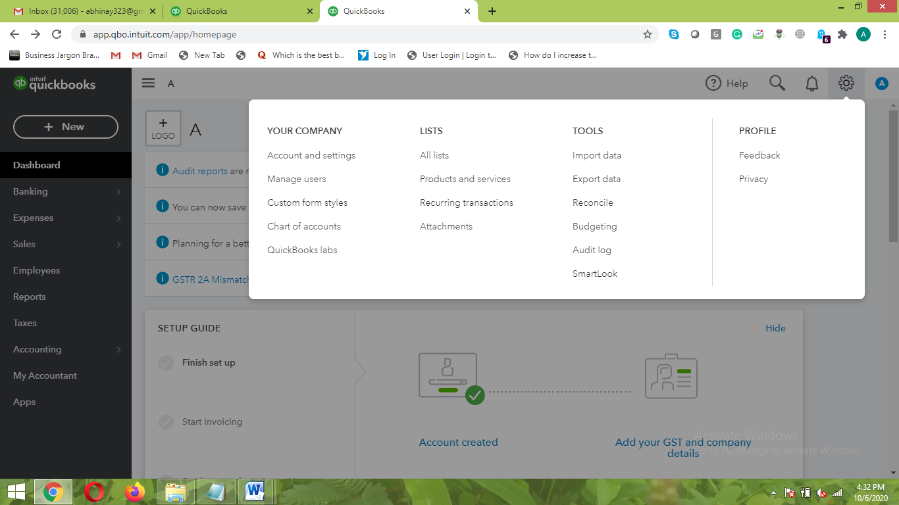

A. Your Company
1. Account and Settings
- Here, you can put the detailed information about the Company like Owner Name, Company Name, Company Address, Company Contact Number, etc.

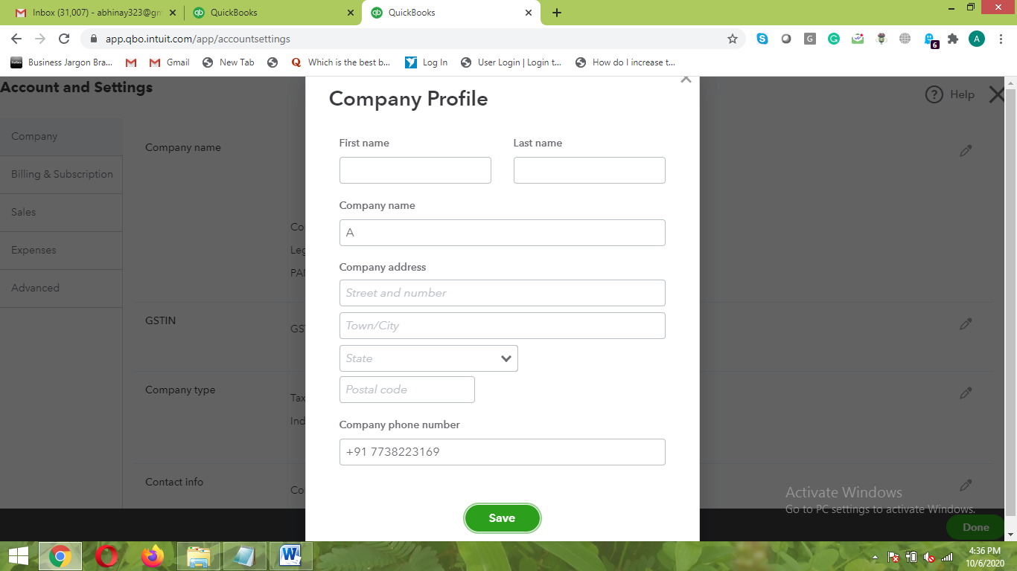

- View the details of the company
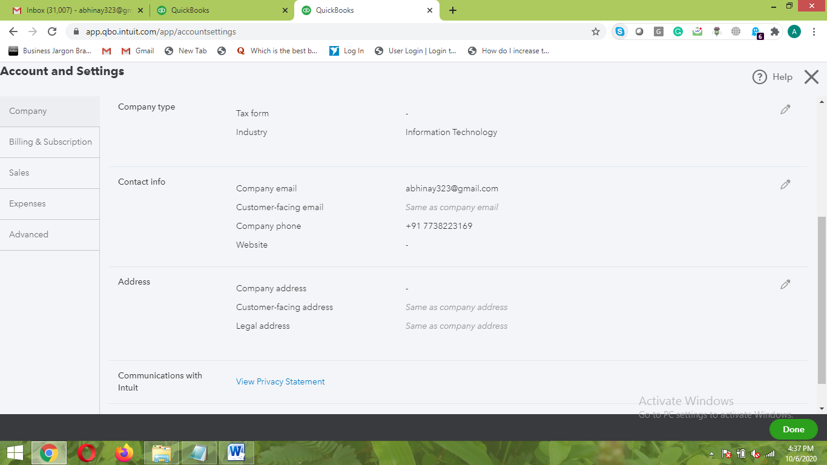

- Billing and Subscription details
- You can get the subscription for the billing along with the Company Id mentioned
- You can subscribe for the details as per the monthly plan mentioned

- Sales
- Get all the sales information in a very detailed manner
- You get the option to activate or deactivate any of the functionality of the Sales process
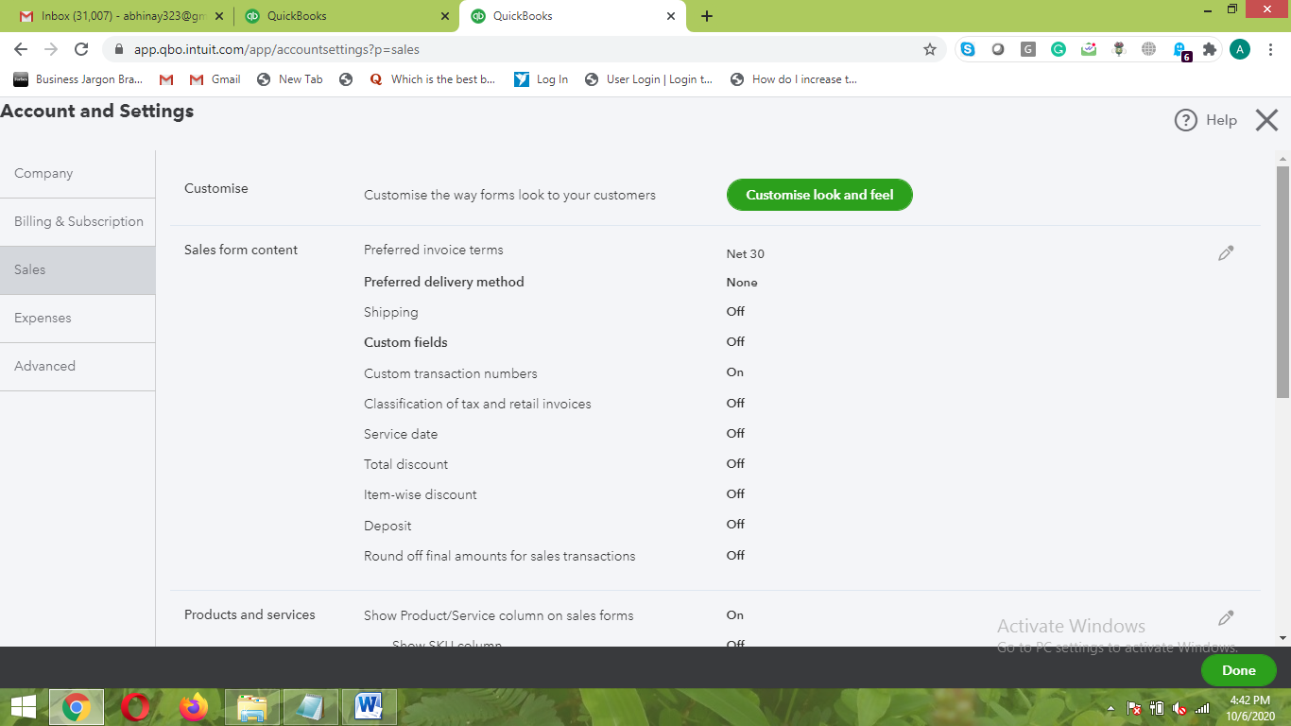

- Expenses
- You can make all the settings for the recording to be made in the Expense section in a very automated way
- You can activate or deactivate any of the section as per your need

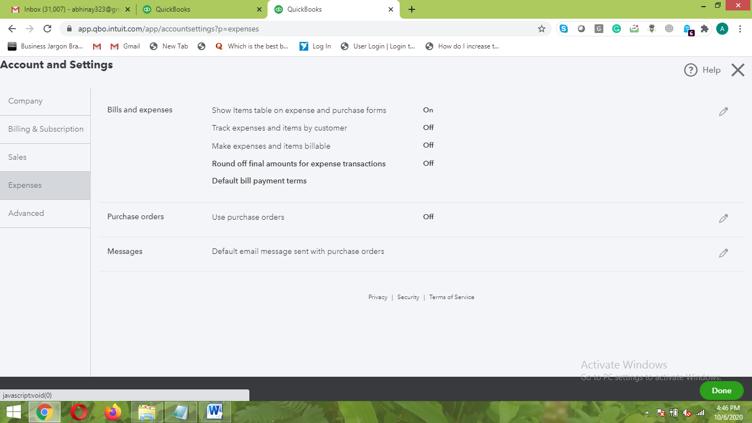

- Advanced
- In the advanced section, you can make all the necessary advance features of the Accounting Process
- The very important aspect here is that you can easily set the month of the Tax year and the financial year.
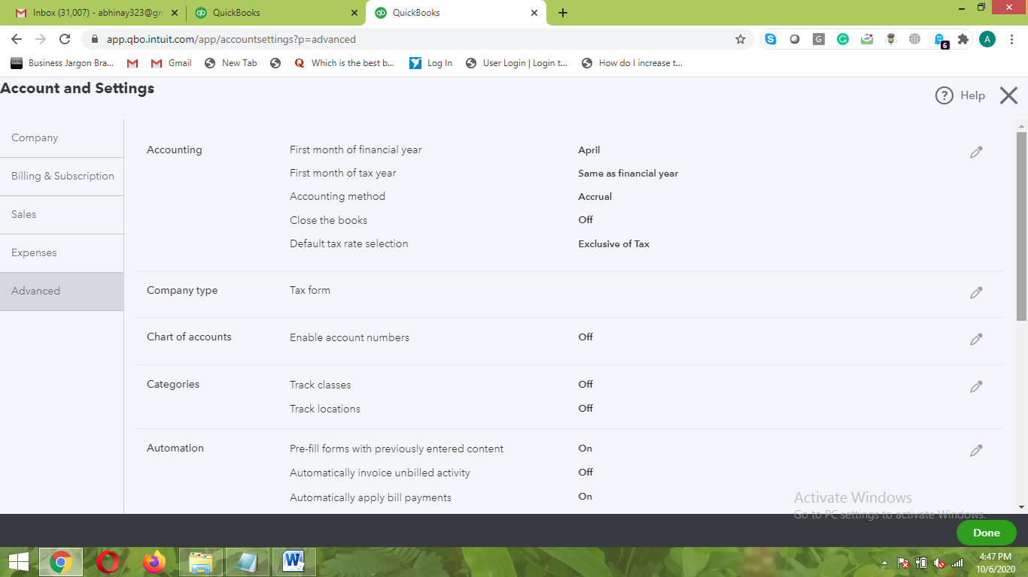

2. Manage Users
- Here you can manage the users of the QuickBooks and know the activity of each of them
- You can assign the user type for each of the User here and “Master admin” will have the authority to assign it to other users

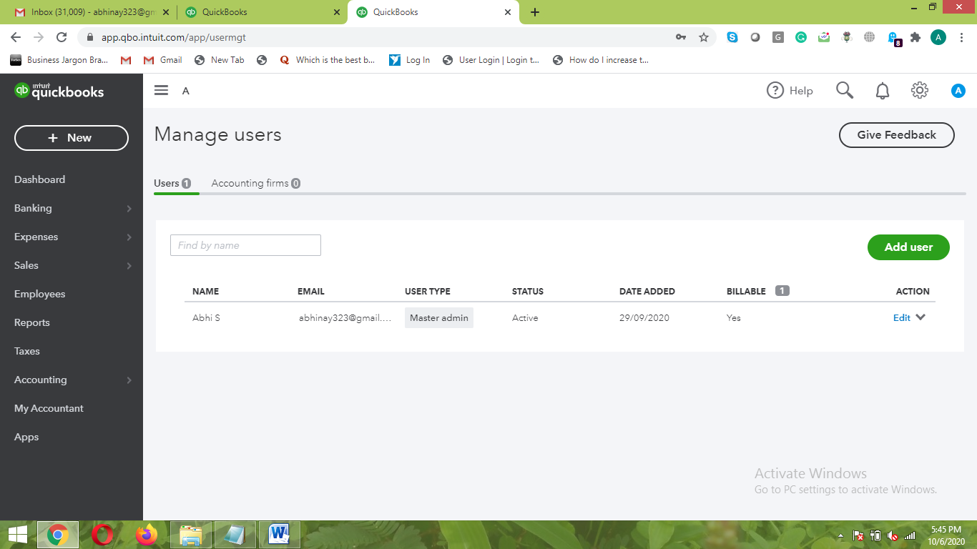

3. Custom form styles
- Here you can customize the form and make the form of your own
- The master admin will have the rights to change the style of the form
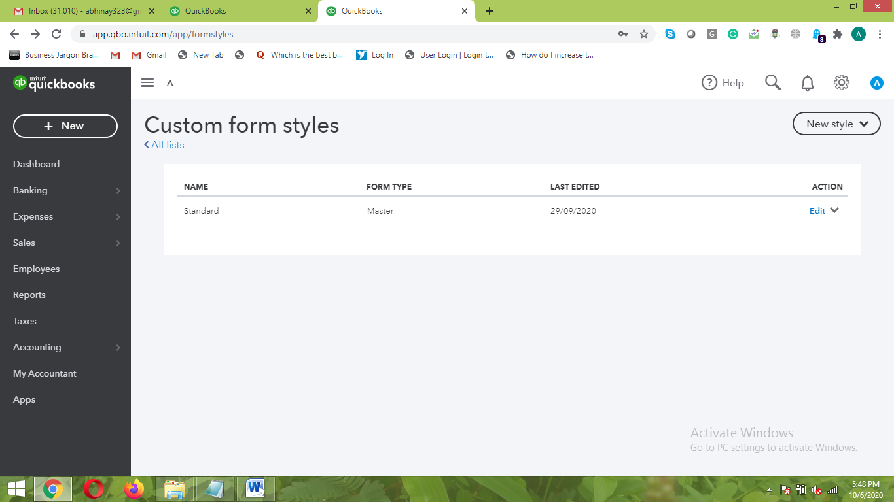

- The new style assist you in changing the style of the form as required
Following style change of the form can be made:
- Invoice
- Estimate
- Cash Memo
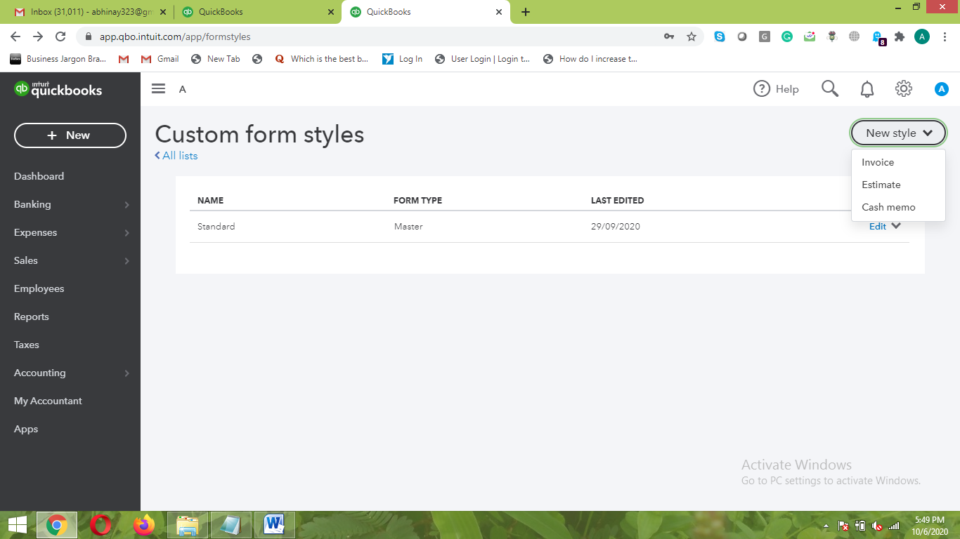

4. Chart of Accounts
- Chart of accounts helps to view all the accounting transactions in the business
- You can make the settings of the relevant taxes applicable for each of the transactions
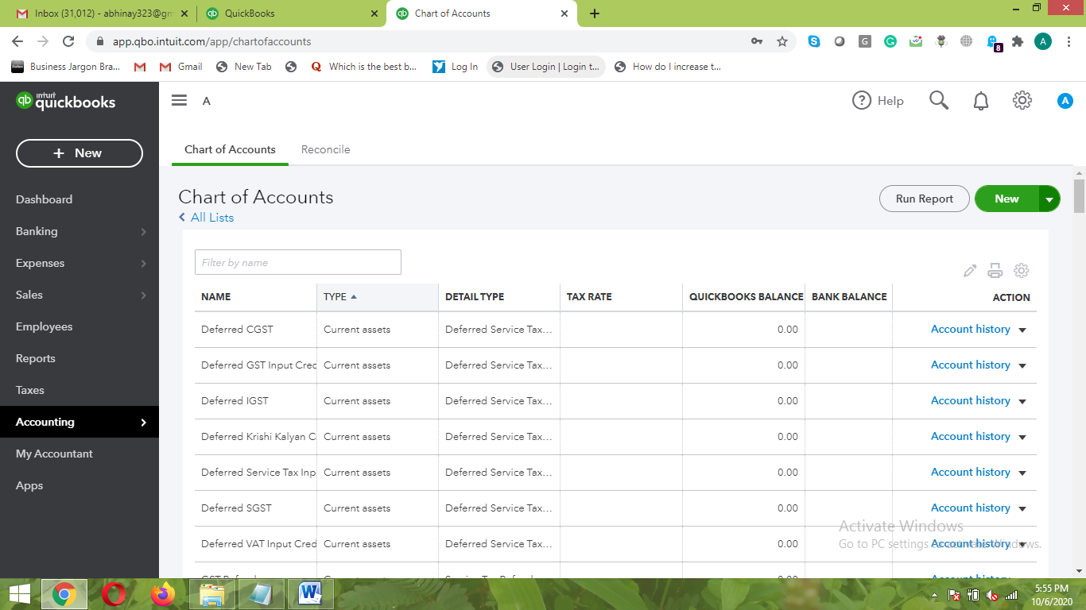

5. QuickBooks Labs
- QuickBooks Labs allows you to use different types of the Themes and Styles as per your liking
- Some of the popular stuff found in the QuickBooks Labs are QuickBooks Themes, Cash Flow Dashboard Widget, Import Style, Community Reports, etc.
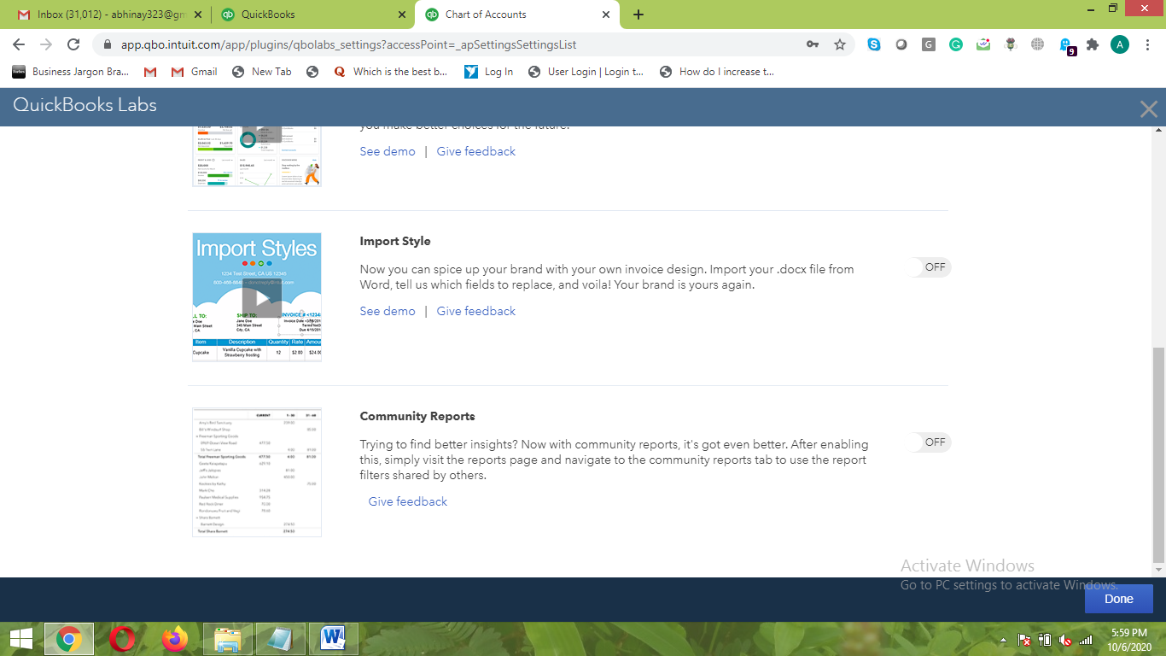

B. Lists
1. All Lists
- Here you can view the important attributes of QuickBooks at one place
- You can make the necessary changes in each of them as per the requirement
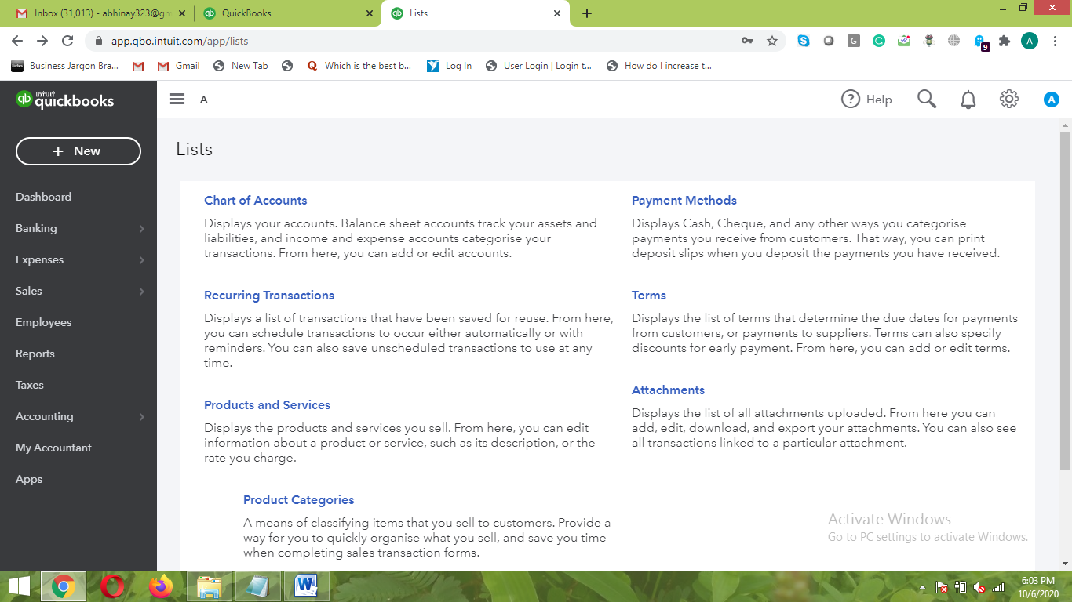

2. Products and Services
- In Products and Services section, you can make the necessary changes in the settings for several attributes related to it
- You can even add the product or services in this section
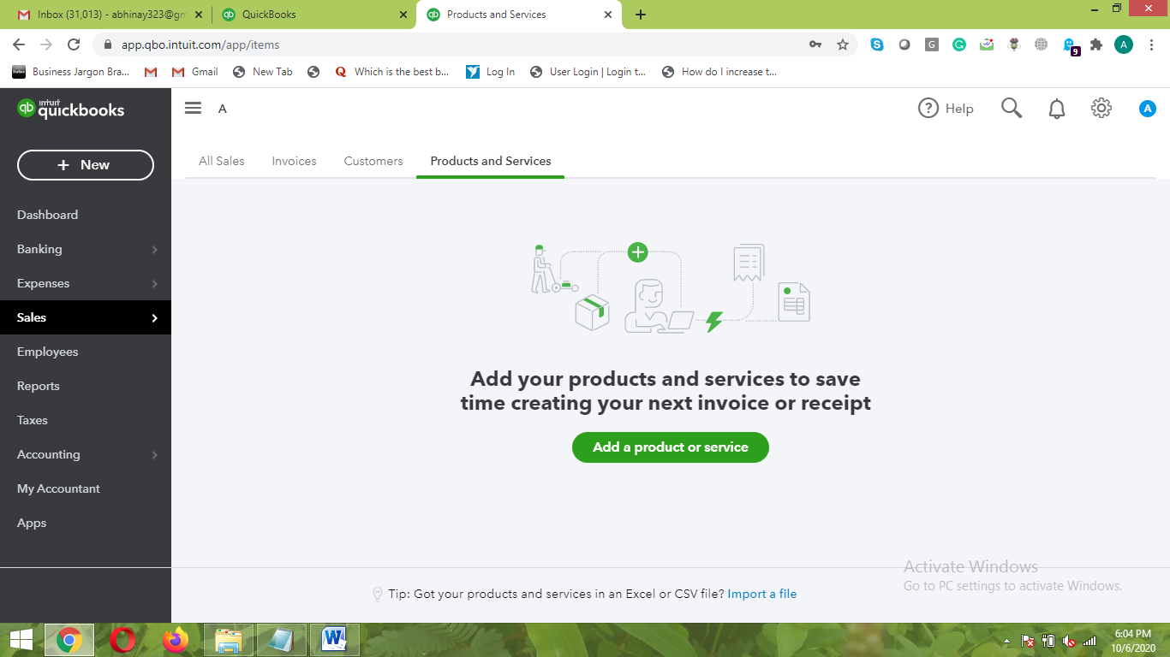

3. Recurring Transactions
- You can make the settings for the different types of recurring transactions happening in the business
- You can even get the list through “Reminder List”.
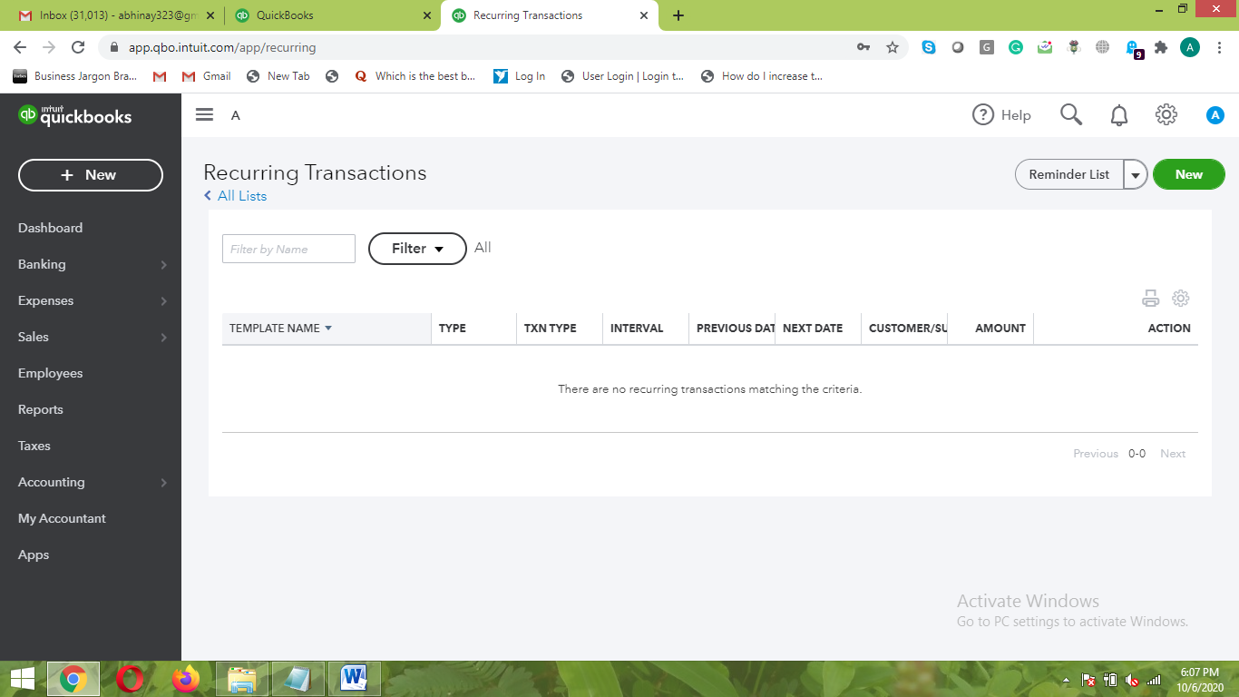

- Here you have very nice option to select the Recurring Transactions as per the “Transaction Type”
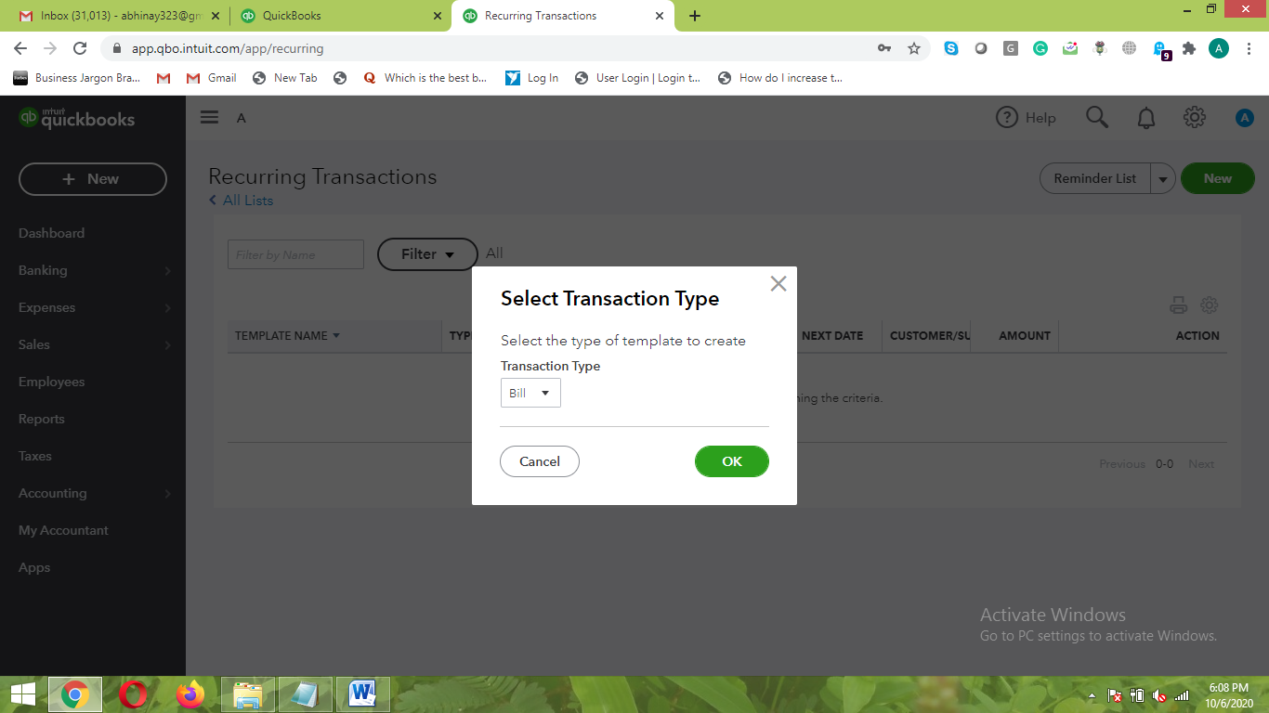
4. Attachments
- You make the attachments of necessary documents in this section
- This will help to give more insight to accounting aspect with related documents of the business
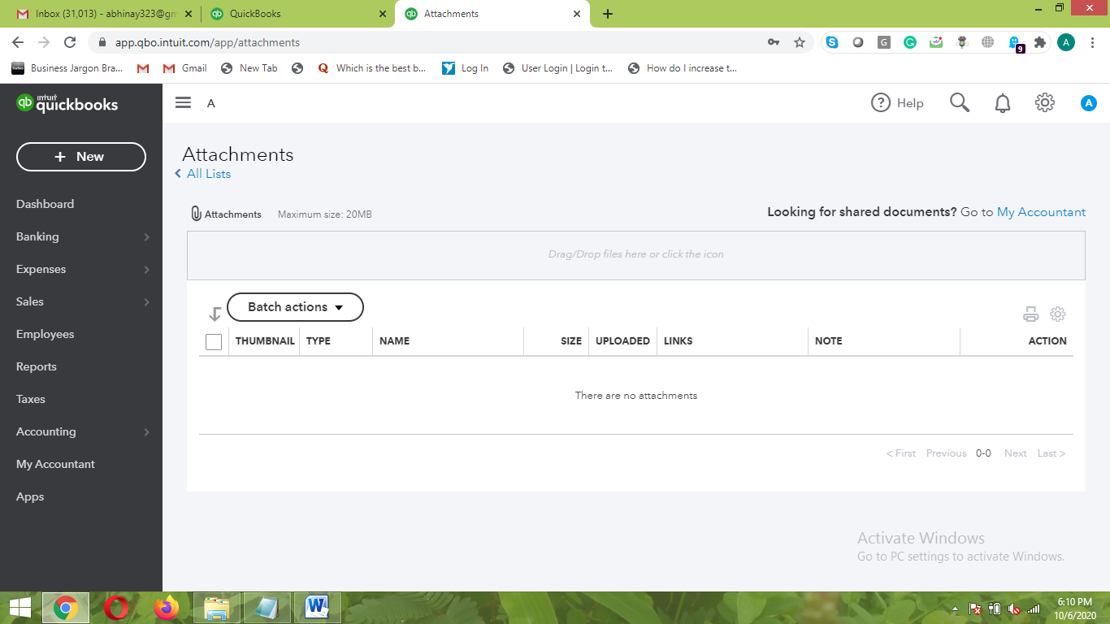

C. Tools
1. Import Data
- Here you can make setting to bring the already existing data in the QuickBooks
- All kinds of data including Customers, Bank Data, and various other data can be imported here
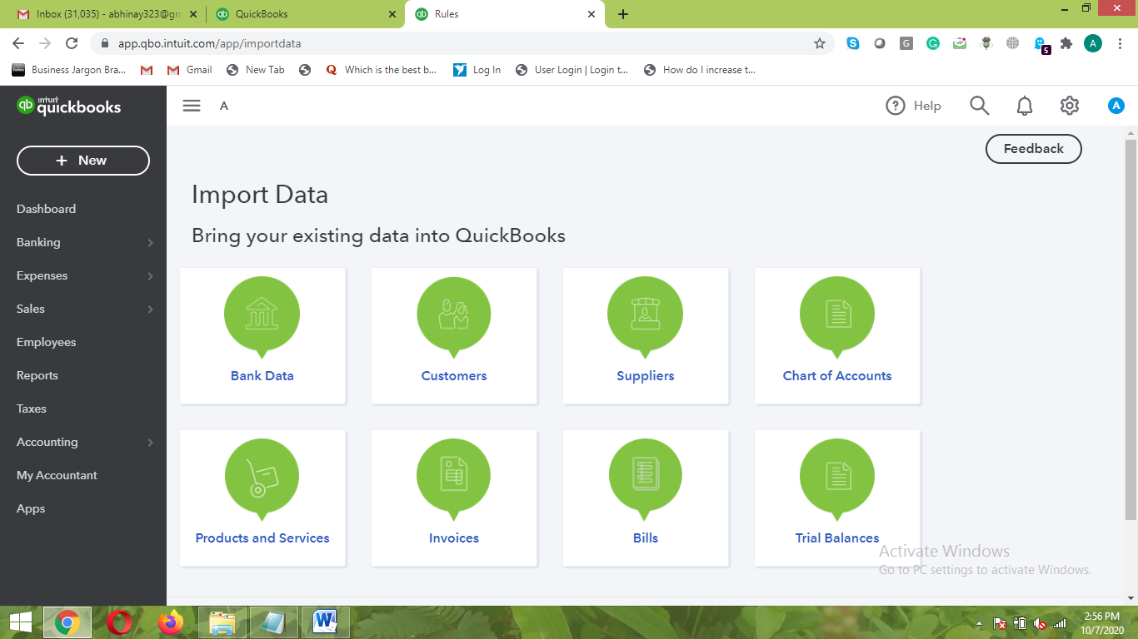

2. Export Data
- Here, you can make settings to export data from QuickBooks to external resources like Excel sheet
- The data can be exported to Profit & Loss Statement, General ledger, and few Accounting entities
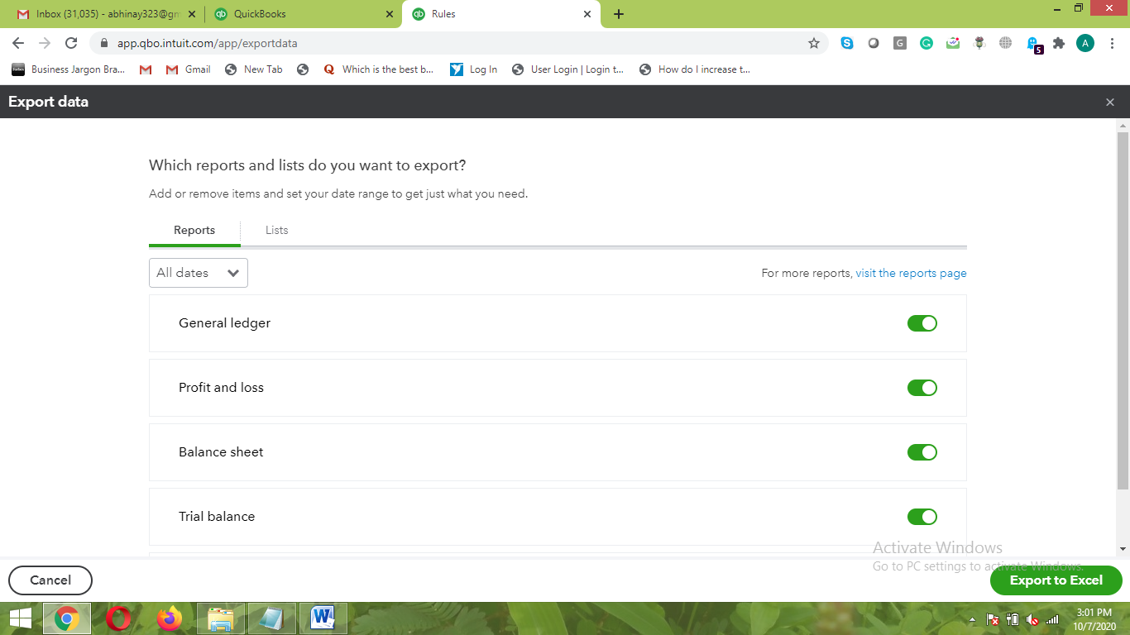

3. Reconcile
- Here setting can be made for checking the accounting books with those of the Bank transactions
- Allows you to keep the things systematic way for tax filing
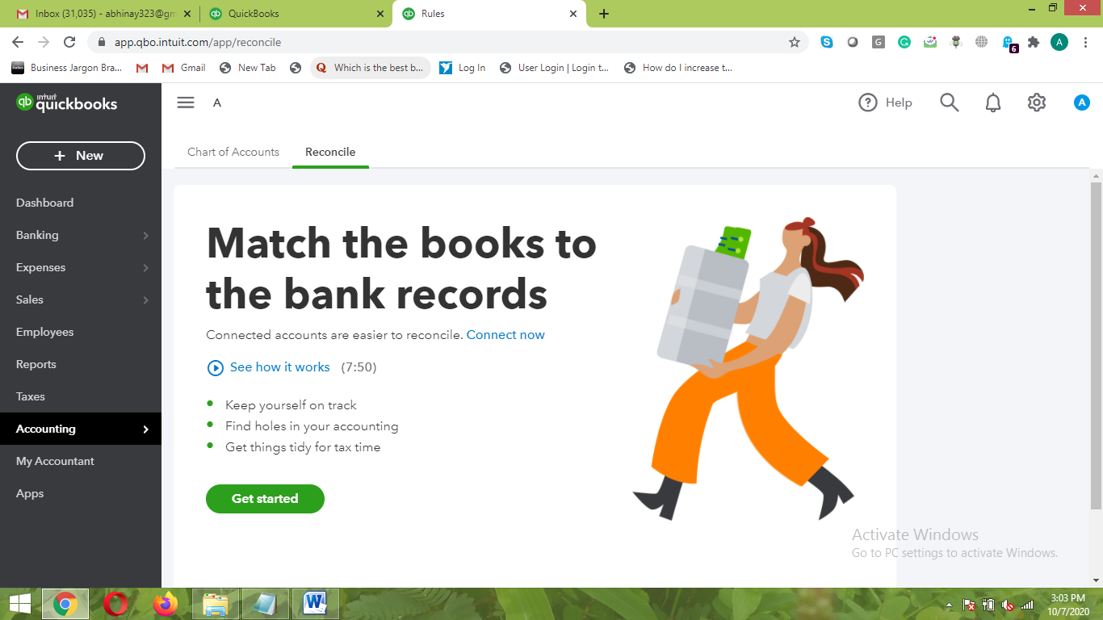

4. Budgeting
- You can make the settings for the budgeting of the finance for various business activities
- Here you can prefix the date and the milestone which you need to achieve bringing that can help bring effectiveness in the business
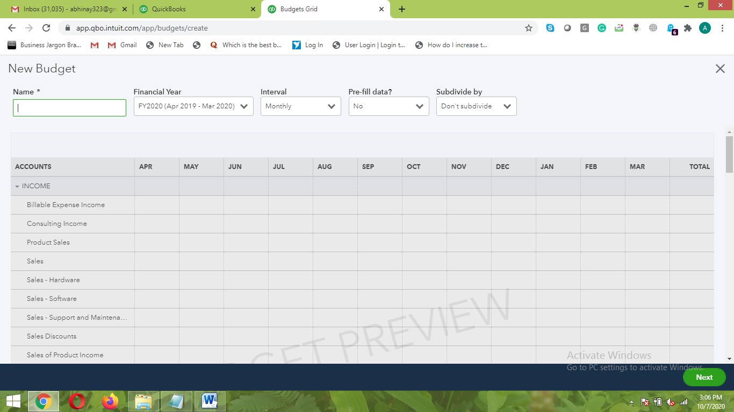

5. Audit Log
- This is one of the important features of QuickBooks where you can check the Log details who have accessed the QuickBooks account.

- You even get the option to set the Columns that can be viewed in the Audit Log
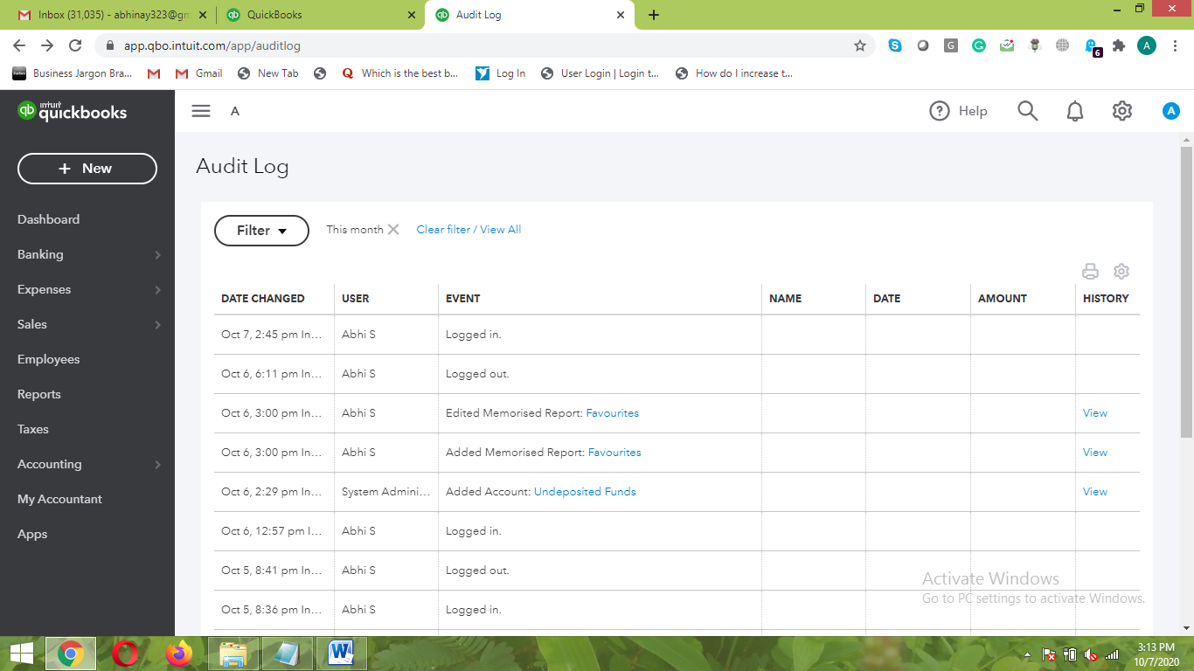

Infographics:
How does QuickBooks useful for business? QuickBooks can handle all the Accounting related aspects of the business in easier way.
Benefits of QuickBooks:
- Record all the financial transactions in the business
- Generate important reports necessary for the business
- Assign the task for different users of the QuickBooks
- Automate the book entry process making it simpler for filing the tax in simpler way
This is the way to make use of QuickBooks to get the Accounting of the business in a proper way.

